**Mod 5: Critical Thinking**

Alex Mehler

CSU Global

CSC450-1

Dr. Bindu George

June 30, 2024

**Execution:**

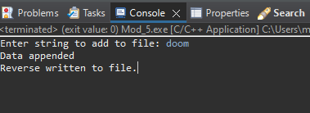

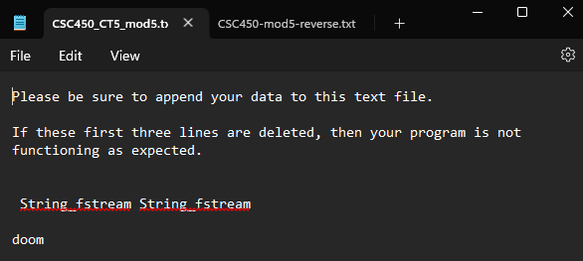

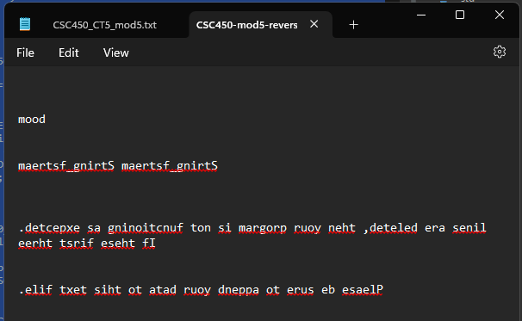

**Code:**

**#include**<iostream>

**#include**<fstream>

**#include**<algorithm>

//Standard namespace declaration

**using** **namespace** std;

**int** **main**() {

**string** input;

**fstream** f;

f.open ("CSC450_CT5_mod5.txt", **ios**::*app*);

**if** (!f) {

cout << "File doesn't exist!";

}

**else** {

cout << "Enter string to add to file: ";

**getline**(cin, input);

f << "\n" << input;

cout << "Data appended\n";

f.close();

}

**string** file;

f.open("CSC450_CT5_mod5.txt");

**getline**(f, file, '\0');

f.close();

**reverse**(file.begin(), file.end());

**fstream** f2("CSC450-mod5-reverse.txt");

f2 << file;

f2.close();

cout << "Reverse written to file.";

**return** 0;

}

**Git:**

https://github.com/SevRnce/c_mod_5